7.6 Worksheet

Slope

Find the slope of each line.
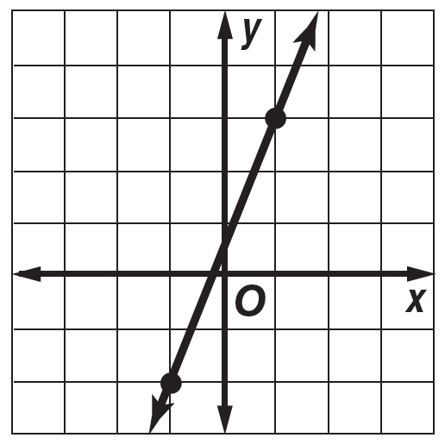
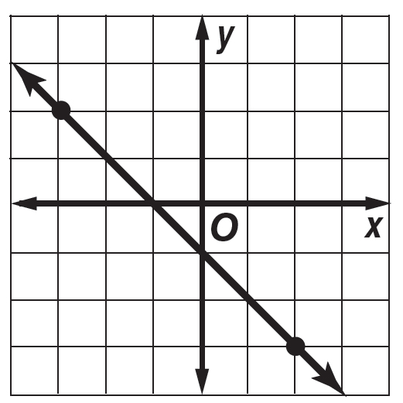
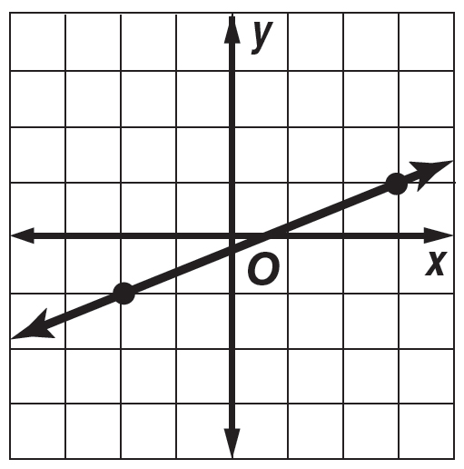
1. 2. 3.

The points given in each table lie on a line. Find the slope of the line. Then graph the line.
x | –1 | 1 | 3 | 5
y | –2 | 0 | 2 | 4

x | –1 | 2 | 5 | 8
y | 3 | –1 | –5 | –9

x | –2 | 3 | 8 | 13
y | –2 | –1 | 0 | 1

4. 5. 6.

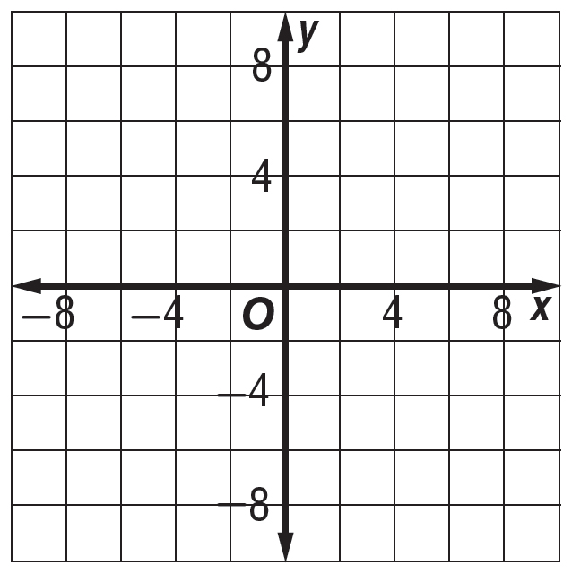
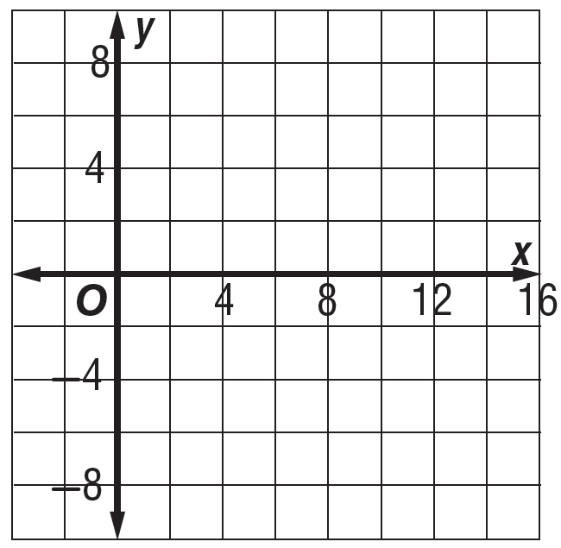
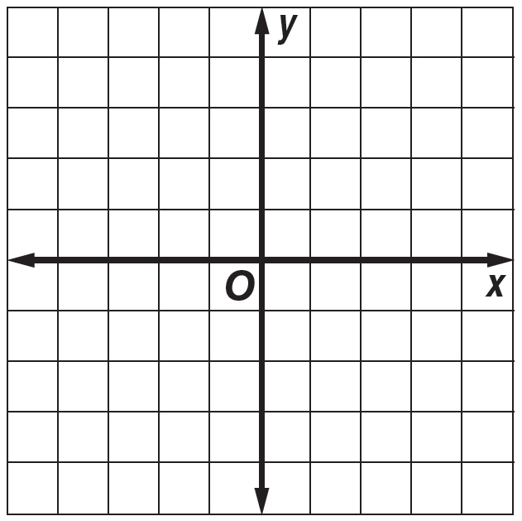

7. HOMES Find the slope of the roof of a home that rises 8 feet for every horizontal change of 24 feet.
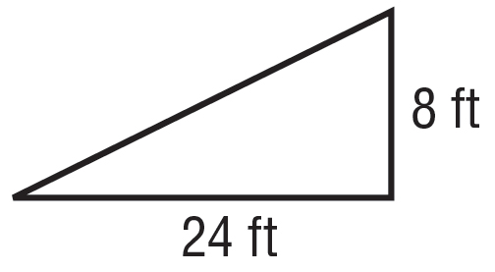
8. MOUNTAINS Find the slope of a mountain that descends 100 meters for every horizontal distance of 1,000 meters

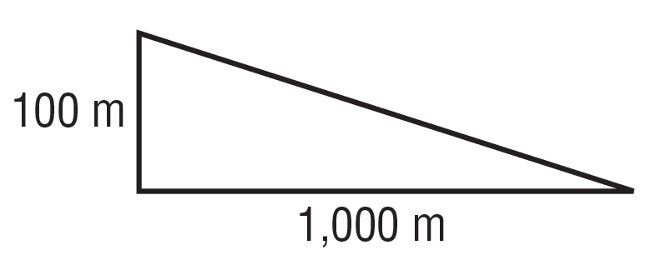

Find the slope of the line that passes through each pair of points.

9. A(1, 3), B(4, 7) 10. C(3, 5), D(2, 6) 11. E(4, 0), F(5, 5)

