Int 1 Ch 9 Review SCORE __________

Write the letter for the correct answer in the blank at the right of each question.

For Exercises 1-3, use the spinner at the right. What is each probability written as a fraction in simplest form?

1. P(C)
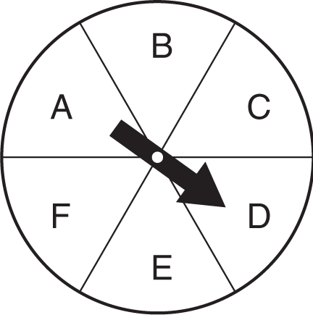

2. P (vowel)

3. P (not D)

For Exercises 4-6, what is the total number of outcomes in each sample space?

4. picking a month of the year and tossing a coin

5. rolling a number cube and tossing a nickel

6. choosing a setting on a washing machine from regular, delicate, or extra dirty; hot, warm, or cold water; regular rinse or extra rinse

7. What is the total number of outcomes for choosing a number from 1 to 10 and a day of the week? Use the Fundamental Counting Principle.

8. A store is handing out coupons worth 10%, 15%, 20%, or 25% off. Each coupon is equally likely to be handed out. Which of the following models could be used to simulate this situation?
F. flipping a coin four times
G. spinning a spinner with four equal sections
H. rolling a number cube labeled one through six one time
I. rolling a number cube labeled one through six four times

1._________________

2. _________________

3. _________________

4. _________________

5. _________________

6. _________________

7. _________________

8. _________________

Int 1 Ch 9 Review (continued) SCORE _________

For Exercises 9 and 10, Bailey tossed a coin 10 times. The results were 7 heads and 3 tails.

9. What is the experimental probability of tossing tails?

10. What is the best comparison between the theoretical and experimental probability of tossing heads?
F. The theoretical probability is greater than the experimental probability.
G. The theoretical probability is less than the experimental probability.
H. The theoretical probability is equal to the experimental probability.
I. The theoretical probability is not related to the experimental probability.

11. A bag contains 4 red marbles and 2 white marbles. A marble is selected, kept out of the bag, and then another marble is selected. What is
P(red, then white)?
A. $\frac{4}{25}$ B. $\frac{2}{9}$ C. $\frac{4}{15}$ D. $\frac{1}{3}$

Find each value.

12. P(8, 3)
F. 6 G. 24 H. 336 I. 512

13. P(10, 4)
A. 14 B. 40 C. 5,040 D. 10,000

14. P(12, 3)
F. 15 G. 36 H. 360 I. 1,320

A number cube labeled one though six is rolled and a letter is selected from the word MUSIC. Find each probability.

15. P(2 and S)
A. $\frac{1}{5}$ B. $\frac{1}{6}$ C. $\frac{1}{11}$ D. $\frac{1}{30}$

16. P(6 and consonant)
F. $\frac{1}{10}$ G. $\frac{1}{6}$ H. $\frac{3}{5}$ I. $\frac{1}{30}$

17. A jar contains 5 blue marbles, 6 yellow marbles, and 4 green marbles. What is the probability of randomly choosing a yellow marble, not replacing it, and then choosing a blue marble?
A. $\frac{2}{5}$ B. $\frac{5}{14}$ C. $\frac{1}{7}$ D. $\frac{2}{7}$

9._____________

10. _____________

11. _____________

12. _____________

13. _____________

14. _____________

15. _____________

16. _____________

17. _____________

