Name _____________________________________ Per ________ Date __________
Intermediate II Chapter 7 Review
You MUST show ALL of your work for full credit
7.1 Congruence and Transformations
1. Determine whether to figures are congurent using transfromations. Explain your reasoning.  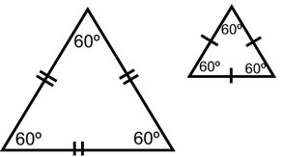 | 2. Determine whether triangle BAC and QPR are congurent using transfromations. Explain your reasoning.  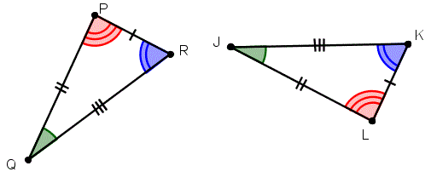
7.2 Congruence
Use the two triangles at right to answer 4-6

4. Write 3 congurence staments comparing congruent parts of the triangles shown. | 5. In the quilt design shown, PQR $≅$ JKL. $∠KJL=33°$ and $∠JKL=73°$ What is the measure of $∠PQR?$ |  | 6. Refer to the figure from question 5. Assume $∠QPR$ is a right angle. Find the measure of $∠JLK$.
7.3 Similarity and Transformations
7. Determine whether the two figures are similar using transformations. Explain your reasoning.  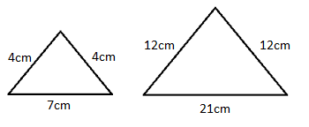 |  | 8. Jenna would like to copy a massive picture that is 4 feet by 6 feet. She enlarges it by a factor of 1:1/4. Then shrinks it by a factor of 3:1. What are the dimensions of the new picture? Are the pictures similar?
7.4/7.5 Similar Polygons
9. The pair of polygons are similar. Write a proportion. Then solve for the length of the missing side.  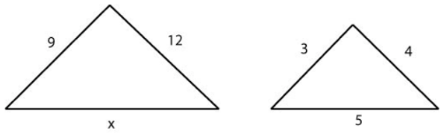 | 10. A projector’s image measures 6 inches wide by 8 inches tall. The width of the actual chip is 3 millimeters. How long is the chip? | 11. What is the length of AD?  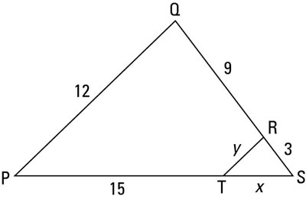
7.6 Slope and Similar Triangles
12. Find the slope between the two points.  (-2, 8) and (-4, 5) | 13. Find the slope of the line  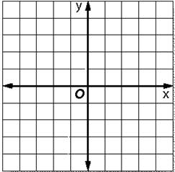
14. Graph each pair of similar triangles. Then write a proportion comparing the rise to the run for each of the similar slope triangles and find the numeric value.
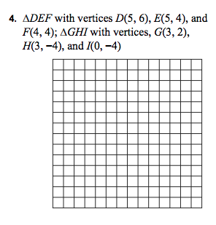

Intermediate II
Chapter 8 Review
Lesson 8.1: Volume of a Cylinder:
Volume of a Cylinder (2 congruent circular bases): V = Bh where B = the area of the base (Base area = $πr^{2}$)
V = $πr^{2}h$
 | 2. | 3.
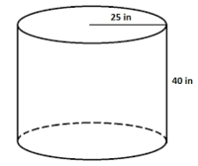 | 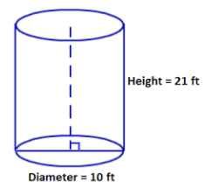 | Find the volume of a cylinder whose diameter is 15 centimeters and whose height is 10 centimeters.
4. Find the volume of the outer cylinder if the inner cylinder is hollow.
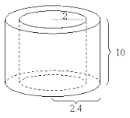
Lesson 8.2: Volume of a Cone:
Volume of a Cone (1 circular base and 1 vertex): V = $\frac{Bh}{3}$ where B = the area of the base (Base area = $πr^{2}$)
V = $\frac{πr^{2}h}{3}$
1.  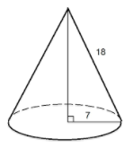 | 2.  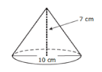 | 3.  If the volume of a cone is 366.3 cubic inches, find the height of the cone.

Lesson 8.3: Volume of a Sphere:
Volume of a Sphere (Ball): V = $\frac{4πr^{3}}{3}$ Volume of a Hemisphere (half): V = $\frac{\frac{4πr^{3}}{3}}{2}$
1.  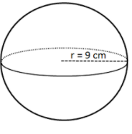 | 2.  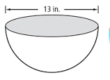 | 3.  Mary is filling a hemispherical punch bowl for a birthday party. The diameter of the punch bowl is 18 inches.  How much punch will the punch bowl hold?  How many 16 cubic inch cup servings will the punch bowl serve?
Extra: Volume of Composite Figures:
Composite Solids: Rules:
1. Always use 3.14 for Pi.
2. Round to the tenths place at the end of each shape.
3. Add the composite shapes together.
1.  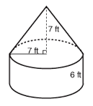 | 2.  