Int II End of Year Final Review

- Filipe surveyed students at his school. He found that 78 students own a cell phone and 57 of those students own an mp3 player. There are 13 students that do not own a cell phone, but own an MP3 player. Nine students do no own either device. Construct a two-way table summarizing the data.  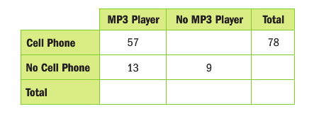 | - Find the relative frequencies by column. Record them in the table. What is the relative frequency of the number of students with no cell phone to the total number of students surveyed?
- Order the following from least to greatest:  $$\sqrt{24}, 5.3, 5\frac{1}{4}, 5.\overline{25}$$ | - What is the definition of an irrational number? List 5 numbers that are irrational.
- Which 2 consecutive integers does $-\sqrt{80}$lie between on the number line? | - Evaluate $5\left(x^{2}-y^{3}\right)+{\left(y-x\right)}^{4}$ for x=-3 and y=5.
- Evaluate each expression for x=-5  $${\left(5x\right)}^{4}$$  $$5x^{4}$$ | - Simplify using exponent rules.  $${\left(6abc^{2}\right)}^{4}{\left(7a^{2}b^{3}c\right)}^{5}$$
- Solve: $\frac{x}{-4}+7=-3$ | - Solve $6\left(x+2\right)=4x-9+2x+11$
- Translate into an equation.  6 less than the quotient of a number and 5 is 13. | - Write an equation to represent the following situation: Ryan has already made 24 cookies and bakes 12 more every hour. He needs 72 cookies total. How many hours does he need to keep baking cookies?
- Solve $8\left(3a+6\right)=9(2a-4)$ | - Solve $8\left(c-9\right)=6\left(2c-12\right)-4c$
- Write and solve an equation: At the fair, Hunter bought 3 snacks and 10 ride tickets. Each ride ticket costs $1.50 less than a snack. If he spends a total of $24.00, what was the cost of each snack? | - Solve $8.0+5v-6.3=4v+2.3+v$
- What is the definition of a function? | - Draw a qualitative graph to represent the situation: Mary is hiking at a constant rate. She slows down for a while because she is tired. Then she stops to take a break. Then she continues hiking at her fastest speed yet.
- Describe how to tell if a function is linear. | - Find the function value  $$f\left(-4\right)for f\left(x\right)=8-12x$$
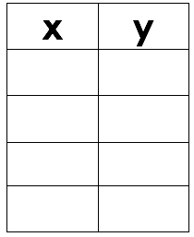  - Create a table representing a linear function. | - Find the slope of the line that passes between the two points.  $$\left(-3, 7\right) and (-6, -4)$$
- Find the slope of the line.  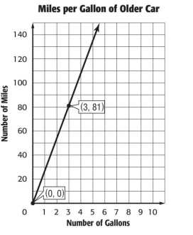 | 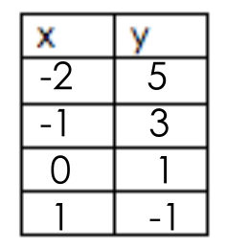  - Find the slope from the table.
- Write an equation for the line in slope-intercept form.  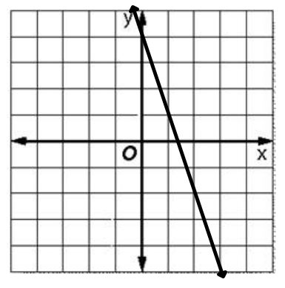 | - Find the solution to the system of linear equations.  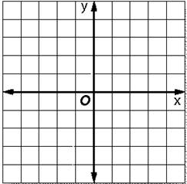  $$y=\frac{1}{2}x-3$$  $$2y+x=-6$$
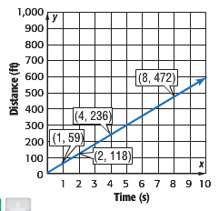  - A zebra’s main predator is a lion. Lions can run at a speed of 53 feet per second over short distances. The graph at the right shows the speed of a zebra. Which animal has a faster speed and by how much? | 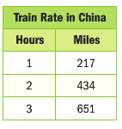  - The function m=140h, where m is the miles traveled in h hours, represents the speed of the first Japanese high speed train. The speed of a high speed train operating today in China is shown in the table. Assume the relationship between the two quantities is linear. If you ride each train for 5 hours, how far will you travel on each?
- Graph the equation $y+4x=5$ | 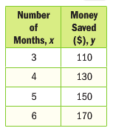  - The table shows how much money Ava has saved. Assume the relationship between the two quantities is linear. Write an equation to represent the situation.
- The scatter plot shows the graduation rate of high school students. Write an equation for the line of best fit.  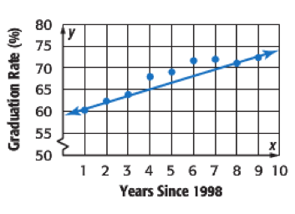 | - Use your equation to make a conjecture for the graduation rate in the year 2020.
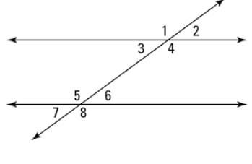  - List all sets of each type of angle.  Alternate interior:  Alternate exterior:  Corresponding:  Supplementary: | - Use the figure from question 33. Find the value of x if $m∠3=10x-20 degrees$ and $m∠4=6x+8 degrees.$
- What is the sum of the interior angles of a triangle. | - Find the value of x in each figure below.  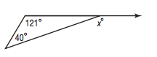  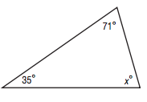
- Find the sum of the interior angles of a dodecagon (12 sides). | - Find the measure of one exterior angle of a regular 14-gon.
- A right triangle has legs that measure 5 ft and 12 ft. What is the length of the hypotenuse? | - Burke drives due North 12 miles and then due East 35 miles and then straight back to where he started. How far did he drive total?
- Eliza usually drives straght to her friend Anna’s house. Today, she drives the long way and goes x miles south and x miles west. If Anna’s house is exactly 24 miles away, what is the value of x? Round to the nearest tenth. | - A right triangle has legs that measure $\sqrt{14} miles$ and $\sqrt{26}$miles. What is the length of the hypotenuse?
- Find the distance between the two points. Round to the nearest hundredth if necessary.  (-9, -3) and (5, -2) | - On a map a park is located at (12.325, 15.546) and the library is located at (16.425, 18.575). How far is it from the park to the library? Round to the nearest thousandth.
- Find the volume of a cylinder with a diameter of 12 feet and a height of 5 feet. | - Find the volume of a cone with a radius fo 4 cm and a height of 8 cm.
- What is the volume of a cylinder with a radius of 2.5 inches and a height of 3.75 inches. | - The volume of a cone is 294.375 cubic feet and the height is 5 feet. Find the radius of the cone.
- Find the volume of a sphere with a radius of 14.5 inches. | - Find the volume of a hemisphere with a diameter of 15 meters.
- I have a sphere full of sand that has a radius of 4 in. Could I empty the sand into a cube that has a side lenth of 4? Explain. | - A cube with a side lenth of 10 cm has a cylindrical hole drilled out of the center. The diamter of the cylinder is 5 cm. Find the volume of the resulting solid.
- Triangle ABC has vertices A(1, 2), B(2, 4), and C(4, 6). Give the coordiates after a reflection across the y-axis. | - Using triangle ABC from question 53 find the coordiates after a roation of 90 degrees counter clockwise about the origin.
- Given the preimage and the image describe the transformation.  A(5, -3) A’(3, 5) | - Describe the translation using translation notation.  B(6, 2) B’(2, -3)
- What transformations create congruent figures? | 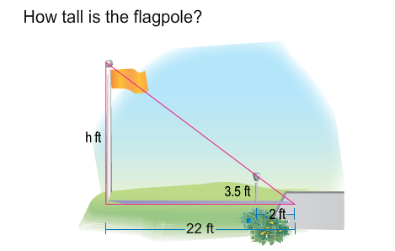  - How tall is the flagpole?
- Which transformations create similar figures? | Graph each pair of similar triangles. Then write a proportion comparing the rise to the run for each of the similar slope triangles and find the numeric value.  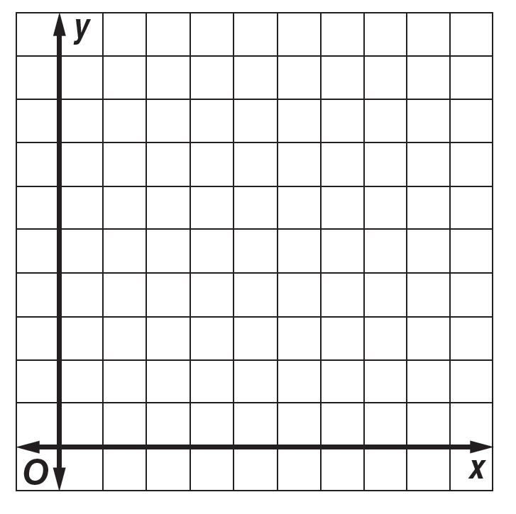  - ∆EFG with vertices E(1,9), F(1,5), and G(2,5); ∆GHI with vertices G(2,5), H(2,1), and I(3,1)
- Find the depth of the water 50 feet from the shore?  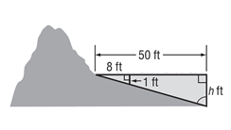 | - Triangles XYZ and MNL are congruent if $m∠XYZ=23 degrees.$ Find $m∠MNL.$
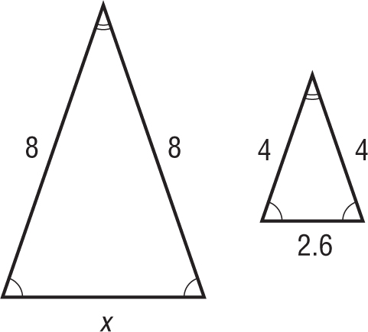  - The triangles are similar. Find the length of the missing side. | - Two triangle are similar. The smaller triangle has a height of 12 inches and a perimeter of 25 inches. The larger triangle has a height of 36 inches. Find the perimeter of the larger triangle.
- A rectangle has a side length of 4 inches and an area of 24 square inches. A larger similar rectangle has a side length of 16 inches. Find the area of the larger rectangle.

